Arts Council for NI:
Committed to Good Disability Practice

The Arts Council for NI took two key approaches to promote access for disabled people:

- Arts Council for NI: Having a Disability Positive Attitude

Crucially, the Arts Council for NI recognised that negative attitude is a key barrier faced by many disabled people, therefore they took a number of steps to enhance awareness and knowledge of disability good practice among its employees:

- All staff received general disability awareness training

- Refresher training was provided every three years for all staff

- All staff received in-depth awareness sessions on autism

- Mental health awareness training for staff

- Staff undertook Disability Positive training and accreditation

Why be Disability Positive?

Many people fear “doing the wrong thing”. They want to help but are unsure how to and feel embarrassed that they don’t know how to serve/interact with disabled people in every setting.

Employers for Disability NI’s key message in Disability Positive seminars is that showing the disabled person that you want to provide good service is the most important thing.

Disability Positive training enhances awareness of:
  - Disability discrimination law and cases
  - Making adjustments for people with disabilities
  - Unfounded myths and stereotypes
  - Appropriate language

Participants undertake a voluntary, confidential assessment to test their knowledge and understanding of disability good practice. Those who pass (pass mark: 75%) are accredited by Employers for Disability NI as Disability Positive and receive a certificate and “Disability Positive” symbol which they can use on name badges etc.

To their great credit, almost 100% of Arts Council staff who undertook accreditation have been accredited as Disability Positive.

How do Arts Council for NI staff show they are Disability Positive?

They are friendly and welcoming, taking time to serve/interact with disabled people, using their disability awareness training to be well informed, flexible and creative. Importantly, if they don’t know how best to serve/interact with the disabled person they ask the person, remembering that they are the expert! Those accredited by Employers for Disability NI also use the Disability Positive symbol to show disabled people that they want to provide an excellent service to all:

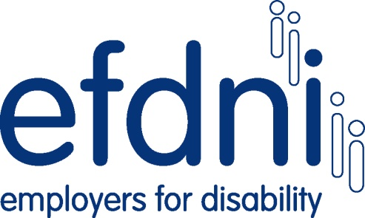
Disability Positive

- Arts Council for NI: Inspiring Others

The Arts Council for NI promotes disabled people’s access to the arts throughout the arts sector by supporting the Arts and Disability Equality Charter:

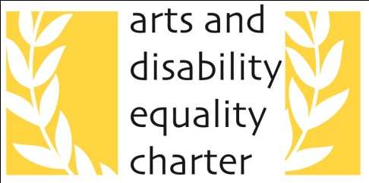

This was developed in response to the barriers identified by Arts Council research into access to the arts for disabled people. It is funded by the Arts Council for NI and is run by the Arts and Disability Forum.

What are the aims of the Arts and Disability Equality Charter?

- To increase access for people with disabilities as audience members, artists, participants or employees

- To help create action plans to engage more with disabled people as customers, staff and volunteers

- To ensure that disabled people influence the way art is provided

- To provide a framework for measuring achievements and formulating action plans

The framework considers access in five areas:

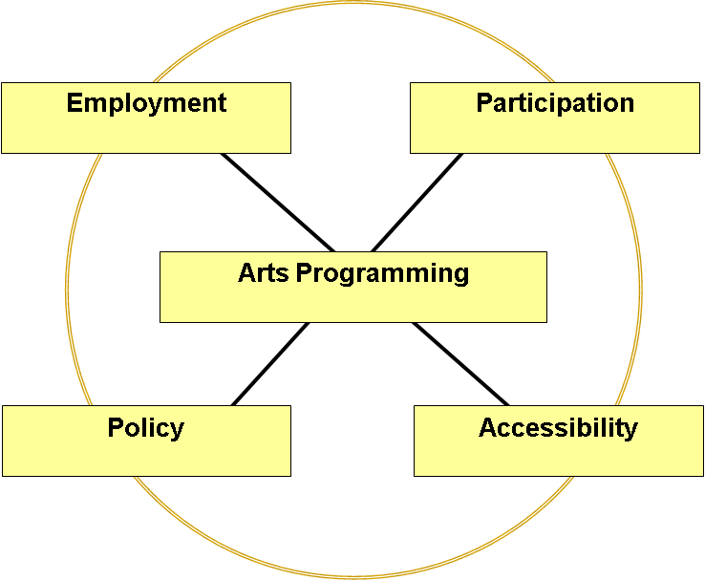

The award has been made to many arts venues, large and small across NI. By supporting this initiative and collaborating with other agencies, the Arts Council has used its influence to make a real difference for disabled people accessing the arts.

